

**A Seminar Report on**

**SEMINAR TITLE**

In partial fulfillment of requirements for the degree of Bachelor of

Engineering In Computer Engineering

SUBMITTED BY:

Name of the student

Under the Guidance of

Dr. Name

**ACKNOWLEDGEMENT**

(Example)

This project would not have been possible without the support of many people. Many thanks to my adviser, Laurence T. Strongarm, who read my numerous revisions and helped make some sense of the confusion. Also thanks to my committee members, Joseph Green, G.L. Foreman, and Celia Barerra, who offered guidance and support. Thanks to the University of Illinois Graduate College for awarding me a Dissertation Completion Fellowship, providing me with the financial means to complete this project. And finally, thanks to my husband, parents, and numerous friends who endured this long process with me, always offering support and love.

**INDEX PAGE**

(**For Both Majors)**

Abstract

**Acronyms and Abbreviations1**

**List of Figures1**

**List of Tables 1**

**CHAPTER 1 : INTRODUCTION1**

1.1 Motivation 2

1.2 Problem Description3

1.3 Organization3

**(For Computer Sciences Major)**

**CHAPTER 2 : LITERATURE REVIEW 4**

2.1 Related Works or Conventional Approaches5

2.2 Challenges 6

2.3 Proposed Approach 7

2.4 Contributions 7

**CHAPTER 3 : METHODOLOGY 8**

3.1 Algorithm 1 9

3.1 Algorithm 2 10

3.2 Overall Process 11

**CHAPTER 4 : EXPERIMENTAL RESULTS12**

4.1 Database Overview13

4.2 Each Step Evaluation14

4.3 Overall Process Evaluation15

4.4 Other Approaches Comparison16

(**For Informatics Major)**

**CHAPTER 2 : PROJECT DESIGN8**

2.1 ERD Diagram 9

2.2 Database Design 10

2.3 Screen Design 11

2.4 Process Model 11

2.4.1 Functional Diagram 11

2.4.2 Data Flow Diagram 11

2.4.3 Use Case Diagram 11

2.5 Proposed System 11

**CHAPTER 3 : TECHNOLOGIES4**

3.1 Server/Client Technologies5

3.2 Web or Mobile Technologies 6

3.3 Computing Technologies 7

2.4 Connection Database Technologies 7

**CHAPTER 4 : APPLICATION12**

4.1 Administrator Applicant13

4.2 User 1 Applicant14

4.3 User 2 Applicant 15

4.4 Computing Results16

(**For Both Majors)**

**CHAPTER 5 : DISCUSSION17**

5.1 Benefits of Proposed Approach18

5.2 Limitations of Proposed Approach19

5.3 Future works20

**CONCLUSIONS21**

**APPENDIX22**

APPENDIX A **:** Description of appendix**22**

APPENDIX B **:** Description of appendix**22**

**REFERENCES22**

**ACRONYMS AND** **ABBREVIATIONS**

BOT Build-operate-transfer

EAP East Asia and the Pacific

GDP Gross domestic product

IADB Inter-American Development Bank

IBRD International Bank for Reconstruction and Development

IFC International Finance Corporation

IFIs International financial institutions

LAC Latin America and the Caribbean

MICs Middle-income countries

**List of Figures**

Figure 1.1. An Example figure. . 2

Figure 1.2. An Example figure. . 3

Figure 1.3. An Example figure. . 4

Figure 2.1. An Example figure. . 5

Figure 2.2. An Example figure. . 6

Figure 2.3. An Example figure. . 7

Figure 3.1. An Example figure. . 8

Figure 3.2. An Example figure. . 9

Figure 3.3. An Example figure. 10

**List of Tables**

Table 1.1. An Example table. . 2

Table 1.2. An Example table. . 3

Table 1.3. An Example table. . 4

Table 2.1. An Example table. . 5

Table 2.2. An Example table. . 6

Table 2.3. An Example table. . 7

Table 3.1. An Example table. . 8

Table 3.2. An Example table. . 9

Table 3.3. An Example table. 10

**Abstract (Example)**

For some applications, such as image recognition or compression, we cannot process the whole image directly for the reason that it is inefficient and unpractical. Therefore, several image segmentation algorithms were proposed to segment an image before recognition or compression. Image segmentation is to classify or cluster an image into several parts (regions) according to the feature of image, for example, the pixel value or the frequency response. Up to now, lots of image segmentation algorithms exist and be extensively applied in science and daily life. According to their segmentation method, we can approximately categorize them into region-based segmentation, data clustering, and edge-base segmentation. In this tutorial, we survey several popular image segmentation algorithms, discuss their specialties, and show their segmentation results. Moreover, some segmentation applications are described in the end.

*Keywords - image segmentation* *; frequency response ; region-based segmentation ; data clustering ; edge-base segmentation.*

**CHAPTER 1: INTRODUCTION**

* 1. **Motivation**

(Example)

The human eye perceives rays of light and the human brain perceives people, cars, buildings, and all the objects that make up the world **[1]**. A camera perceives rays of light, and a computer perceives dots of color. This disappointing disconnect between the human and computer visual experiences has long frustrated the field of computer vision. How can colored dots be converted into a cup of coffee? How can we program computers to detect and recognize objects?

To overcome this issue, much of the work in object recognition has resigned itself to using subsets of pixels in a fixed shape. Image classification considers only one subset, the entire image, and tries to classify whether an object exists anywhere in a scene. Examples of image classification techniques are **[2, 3, 4]** among others. There are also many patch-based approaches, which consider pixel information in a fixed-shape subset of the image defined a priori. Boxes or rectangles are a natural shape choice given that pixels are usually arranged in a grid pattern **[5-8]**

* 1. **Problem Description**

(Example)

One possible approach to properly identifying the pixels which belong in an object mask is to learn the shape of the object. There exist a number of top-down methods which attempt to model the outline or silhouette of an object, such as. Additional approaches subdivide an object into a number of rigid parts and then model each part’s shape and their relative configuration. These methods show promise for rigid objects, or objects with a small number of rigid parts, such as a fire hydrant, or even the side view of a particular breed of horse running1.

Let us consider, however, all of the objects in Figure 1.2. These objects range from rigid objects such as a car, to extremely deformable objects such as the cheetah with its flexible body and tail in a variety of positions, all the way to objects whose shapes not only change but in fact are uninformative, such as water. These objects have a very large set of shapes they can take, so top-down object knowledge does not sufficiently limit the possible sets of pixels which might make up their object masks. We require a data-driven, or bottom-up approach, which can group together some of the pixels and so reduce the size of the configuration space.

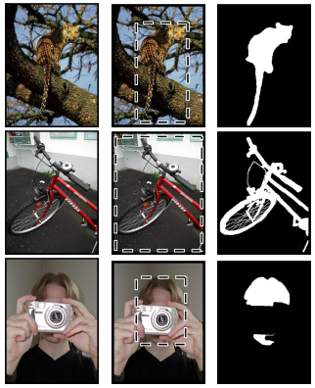

(a) Image (b) Bounding box (c) Object mask

**Fig. 1.** Examples of (a) images, (b) bounding boxes surrounding objects of interest, and (c) pixel-accuracy object masks.

In summary, this dissertation discovers and addresses a set of challenges related to incorporating image unsupervised segmentation into an object recognition and object segmentation framework. By performing a set of rigorous experiments regarding the relationship between segmentation regions and object masks, we motivate our approach.

* 1. **Organization**

The rest of the report is organized as follows,

• In Chapter 2, we present the introduction, methods, results and discussion of the extension of the random walker segmentation algorithm to 2nd order DT-MR images.

• In Chapter 3, we present the introduction, literature review, results and discussion on the comparison between segmentations performed on 2nd and 4th order DT-MRI data.

• In Chapter 4, we present the introduction, methods, results and discussion on the discrimination of brain tissue.

This is a footnote. A place to put additional information.

**(For Computer Sciences Major)**

**CHAPTER 2: LITERATURE REVIEW**

* 1. **Related Works or Conventional Approaches**

Famous techniques of image segmentation which are still being used by the researchers are Edge Detection, Threshold, Histogram, Region based methods, and Watershed Transformation. Since images are divided into two types on the basis of their color, i.e. gray scale and color images. Therefore image segmentation for color images is totally different from gray scale images, e.g., content based image retrieval **[9, 10]**. Also which algorithm is robust and works well is depends on the type of image **[11]**. The property of a pixel in an image and information of pixels near to that pixel are two basic parameters for any image segmentation algorithm. It can also be representing as similarity of pixels in any region and discontinuity of edges in image. Edge based segmentation is used to divide image on the basis of their edges. Region based methods used the threshold in order to separate the background from an image, whereas neural network based techniques used the learning algorithm to train the image segmentation process **[12]**.

The result taken from image segmentation process is the main parameter for further image processing research; this result will also determine the quality of further image processing process. Image segmentation algorithms play an important role in medical applications, i.e., diagnosis of diseases related to brain **[13-18]** heart, knee, spine, pelvis, prostate and blood vessel, and pathology localization.

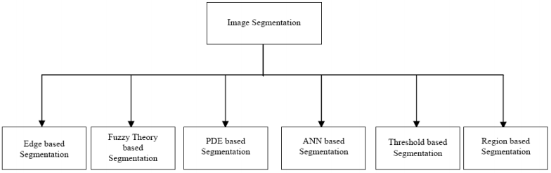

**Fig. ?.** Image segmentation techniques

1. *Edge Based Image Segmentation*

<<Paragraph for the topic here>>

1. *Fuzzy Theory Based Image Segmentation*

<<Paragraph for the topic here>>

1. *Partial Differential Equation (PDE) Based Image Segmentation*

<<Paragraph for the topic here>>

*D. Artificial Neural Network (ANN) Based Image Segmentation*

<<Paragraph for the topic here>>

* 1. **Challenges**
  2. **Proposed Approach**

**<<**Short Description of Each Steps here**>>**

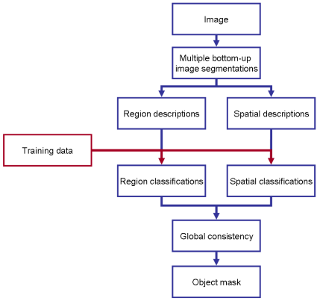

**Fig. ?.** Overview of our algorithm

* 1. **Contributions**

The key contributions of this dissertation include:

• A framework for quantitatively evaluating and comparing segmentation algorithms, including:

– A quantitative measure of segmentation correctness

– The definition of criteria for a useful black-box segmentation algorithm

– A set of experiments to measure those criteria.

**(For Computer Sciences Major)**

**(For Computer Sciences Major)**

**CHAPTER 3: METHODOLOGY**

* 1. **Algorithm 1**

<<Detail information about Algorithm 1>>

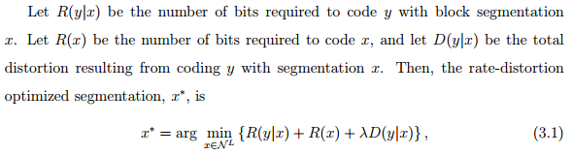

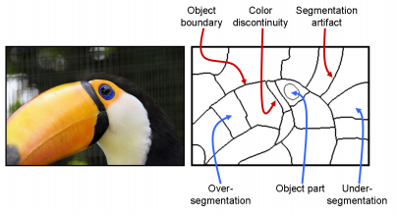

**Fig. ?.** Illustration of the different types of segmentation-generated regions (in blue) and region boundaries (in red). Ideally, region boundaries coincide with object boundaries

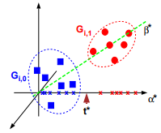

**Fig. ?.** Minimal MSE thresholding.

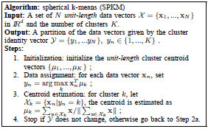

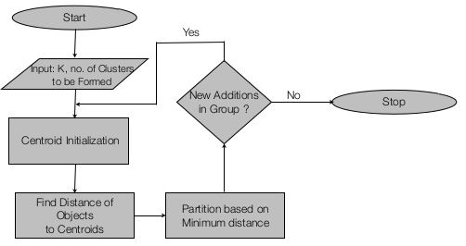

**Fig. ?.** Kmeans algorithm

* 1. **Algorithm 2**

<<Detail information about Algorithm 2>>

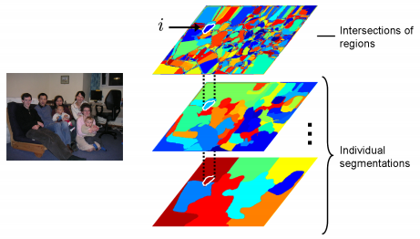

**Fig. ?.** Example of an intersection of regions i and its parent regions in two of the eighteen segmentations. In the top individual segmentation, i’s parent region (in blue) contains the man’s head, while in the bottom individual segmentation i’s parent region (in dark red) contains both the head and parts of the wall and floor. The quality of the individual segmentation regions varies, but the

intersections of regions are almost always contained in one object

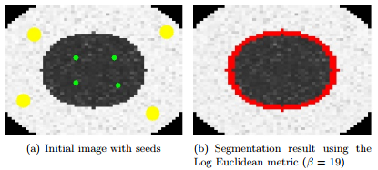

**Fig. ?.** Segmentation of a noisy synthetic 2D DT-MRI slice. The inner seeded disk is correctly segmented from the noisy background.

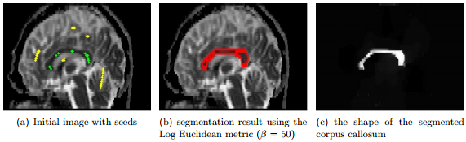

**Fig. ?.** Segmentation of the corpus callosum from a real brain DT-MRI dataset.

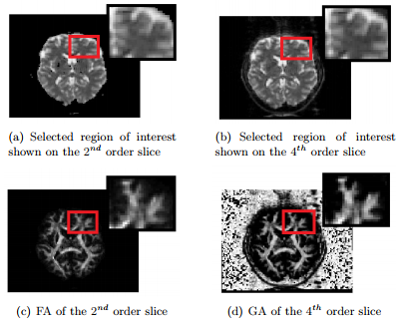

**Fig. ?.** The selected slices and region of interest chosen for the segmentation

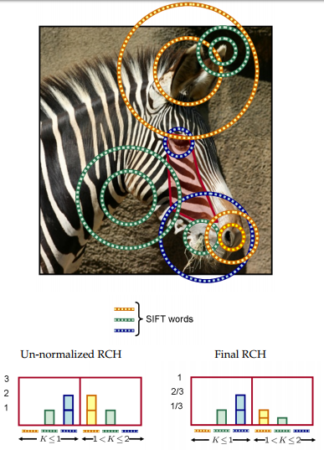

**Fig. ?.** Illustration of the construction of an RCH. The top image shows a region with homogeneous texture, in red, on an image of a zebra. There are several interest points centered at each circle or pair of concentric circles. The SIFT descriptors for these interest points are quantized into three ‘words’, denoted as yellow, green and blue circles.

* 1. **Overall Process**

*Input:* A message in plaintext of any length.

*Output:* A message digest of 128 bit for the input message.

The algorithm works in the following steps:

*Step 1*

Enter the input string.

*Step 2*

Find the equivalent binary string.(Use ASCII conversion for each character used in the message string.)

*Step 3*

1. Append a bit sequence (In this case “01”) to the binary string so that the length of the resulting string is 64 shorter than a multiple of 512.
2. Append 64 more bits by scanning the binary string of step3(i) starting from an arbitrary location (In this case a rule can be implemented to define the starting point as [ length of the string/3 ])

*Step 4*

1. Divide the output binary string of Step3 in 128 bit blocks.
2. Generate a 128 bit binary key using a random number generator.
3. Perform a bitwise operation ( like OR , AND, XOR, followed by Left Shift, Right Shift, zero fill shifting etc.) among the 128 bit block and 128 bit random key.
4. Store the output of Step4(iii) as stepwise message digest.

*Step 5*

1. Perform a bitwise operation among the current stepwise message digest and the previous stepwise message digest.
2. Go to Step4 until all the blocks of input message are exhausted.

*Step 6*

Convert the output of Step5 into corresponding character value and store it as the final message digest.

**(For Computer Sciences Major)**

**CHAPTER 4: EXPERIMENTAL RESULTS**

* 1. **Database Overview**

The Butterflies DataBase

• First used or created by: Lazebnik et al. in 2004 [65].

• Ground truth labels by: Pantofaru et al. in 2006 [86].

• Image source: Internet

• Unlabeled or ‘void’ pixels in the ground truth: No, all pixels are labeled.

• Image sizes: Variable, 150x172 to 900x647.

• Number of classes: 7 plus background

• Number of images: Total = 619, Training = 182, Testing = 437

• Training vs. test division as in the original publication: yes.

• Class names, sizes, and training set vs. testing set division:

Table 4. Description of database.

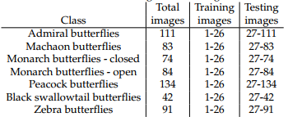

Examples of the Butterflies data set are given in Table 4.1. The task is to differentiate the butterflies from each other, as well as from the background. The butterfly species are similar in many ways, increasing discrimination difficulty. It is especially difficult to differentiate between the two monarch classes which only differ in their pose. Also note that the images are different sizes, and the butterflies themselves vary widely in number and size.

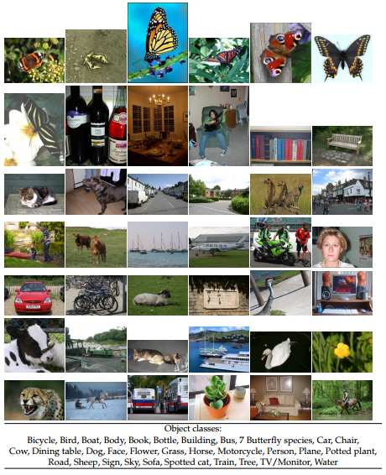

**Fig. ?.** Examples of the objects we will model throughout this thesis.

s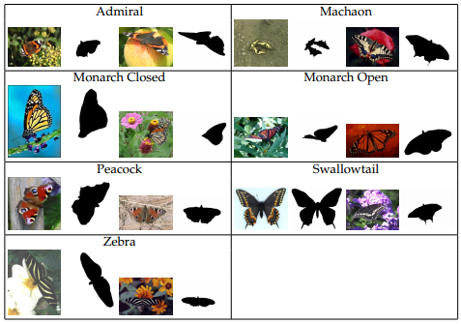

**Fig. ?**. Examples of images and ground truth object segmentation masks from the butterflies’ data set

* 1. **Each Step Evaluation**

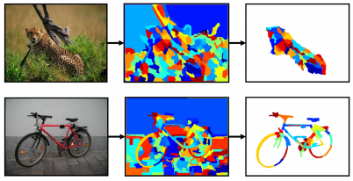

**Fig. ?.** Illustration of selecting and combining segmentation generated regions

* 1. **Overall Process Evaluation**

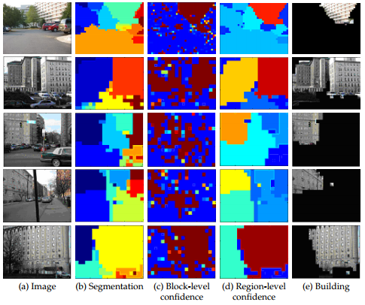

**Fig. ?.** Building classification resulting from using image information. For each image, column (b) shows the unsupervised segmentation (colors are random), column (c) shows the classification of individual blocks (jet colormap), column (d) shows the classification of each region (jet colormap), and column (e) shows the final building localization

* 1. **Other Approaches Comparison**

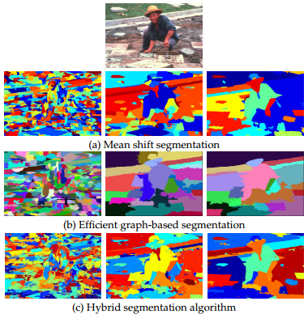

**Fig. ?.** Examples of unsupervised segmentations generated by various algorithms. Segmentations in row (a) were generated by the mean shift-based algorithm, row (b) by the efficient graph-based algorithm, row (c) by the hybrid algorithm, row

Table 4.2. Description of the example table.

|  |  |  |  |  |
| --- | --- | --- | --- | --- |
|  | Indoor | | Outdoor | |
|  | Segmentation | Classification | Segmentation | Classification |
| SVM | Medium | None | None | None |
| EM | Low | Low | Low | Medium |
| Our Approach | High | High | High | Medium |

Table 4.3. Description of the example table.

|  |  |  |  |  |
| --- | --- | --- | --- | --- |
| Previous Results | Approaches | Class 1 | Class 2 | Class 3 |
| K-Means | 32% | 16% | 52% |
| SVM | 19% | 11% | 70% |
| EM | 45% | 19% | 35% |
| Hierarchy Tree | 28% | 18% | 54% |
|  | Our Approach | 44% | 8% | 48% |

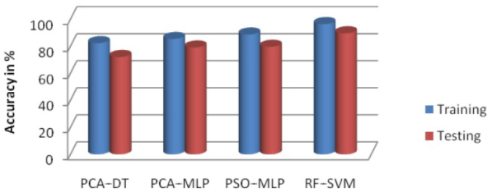

**Fig. ?.** Accuracy Comparison among approaches

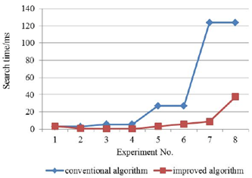

**Fig. ?.** Accuracy Comparison between two approaches

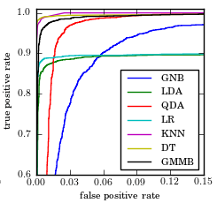

**Fig. ?.** ROC Curve among approaches

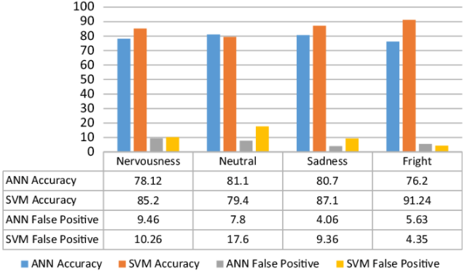

**Fig. ?.** Accuracy among approaches

**(For Informatics Major)**

**CHAPTER 2: LITERATURE REVIEW**

* 1. **ERD Diagram**

The figure below shows an Entity-Relationship Diagram that was drawn in Microsoft Visio as a Database Model Diagram using the Crow’s Foot Notation. Try to interpret the diagram yourself and then read the description that follows, keeping in mind that this diagram is not meant to be an exhaustive representation of the problem domain being modeled.

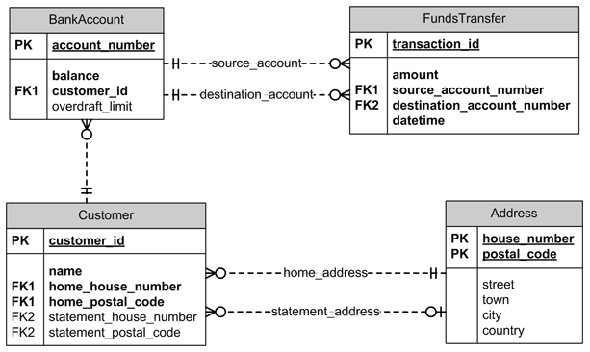

**Fig. ?.** ERD Diagram

A **BankAccount** entity is uniquely identified by the **account_number** primary key attribute. It has a required**balance**attribute (because an account must have a balance) and an optional **overdraft_limit** (because not all accounts have an overdraft facility). The **BankAccount** has a **customer_id** foreign key attribute that identifies the account customer via the relationship to the **Customer** entity.

* 1. **Database Design**

In the Relational Database model, each of the entities including the Associate entities is transformed into a table. The attributes (fields) of each of the entities for the ERD shown in Table ? are as follows.

Table ? User Authentication.

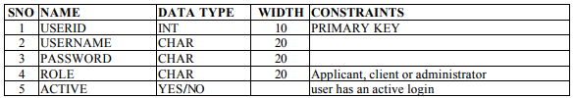

The “role” in the above table describes the relationship of the user with the firm, whether the user is an applicant or a client or the administrator in the firm.

Table ? Employee Applicant.

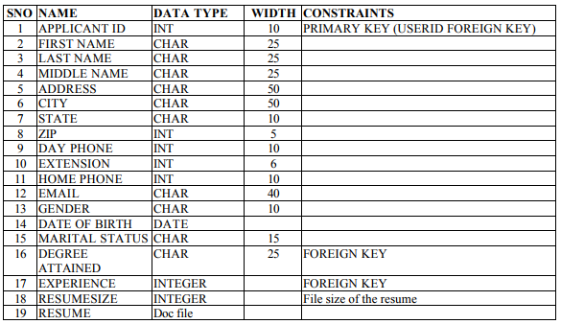

* 1. **Screen Design**

Before implementing the application, the layouts for few a pages were designed. Having these designs provided a guideline for developing the user interface of the application and helped in actual implementation. The initial layouts of the pages are shown in Figures ? to ?

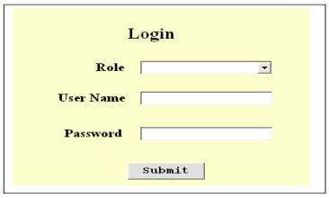.

**Fig. ?.** Login Form

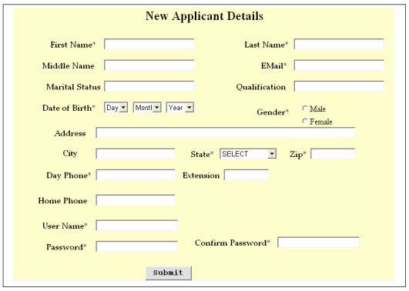

**Fig. ?.** Employee Applicant Registration Form

* 1. **Process Model**

The Process Model shows the overall functionality of the system. Functional Decomposition Diagrams and Data Flow Diagrams are two tools for process modeling. The Decomposition Diagram shows a hierarchical structure of the system while the Data Flow Diagram shows the sequence of events of a business operation.

* + 1. **Functional Diagram**

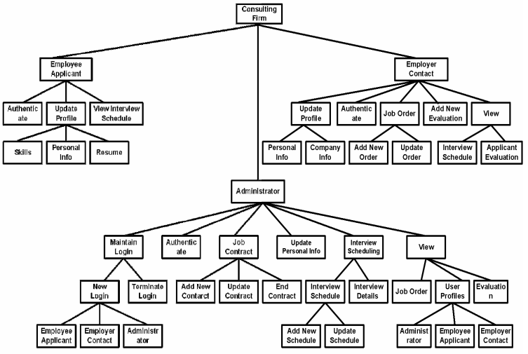

**Fig. ?.** The Functional Decomposition Diagram for the current application

* + 1. **Data Flow Diagram**

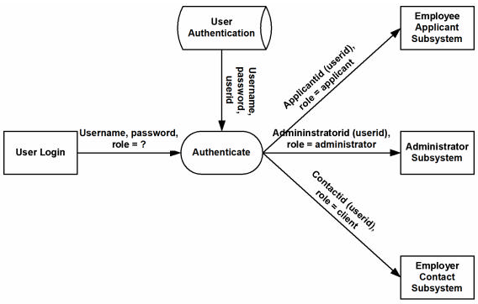

**Fig. ?.** User Authentication DFD

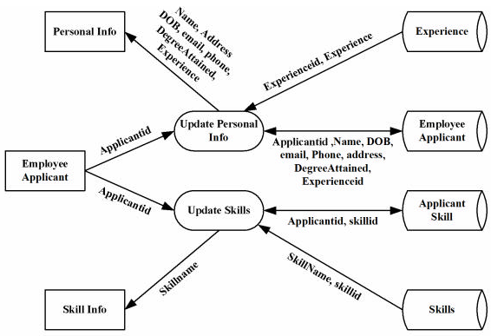

**Fig. ?.** Employee Applicant - Update Profile Detailed DFD

* + 1. **Use Case Diagram**

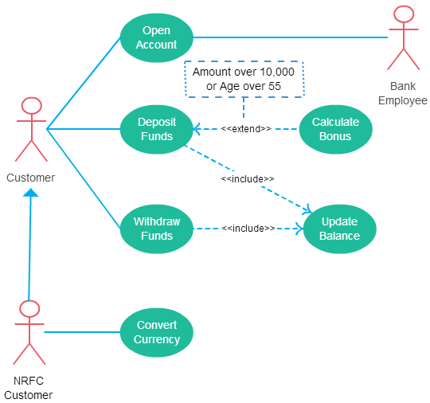

**Fig. ?.** Use Case for Customer

Many people confuse the extend relationship in use cases. As the name implies it extends the base use case and adds more functionality to the system. Here are few things to consider when using the <<**extend**>> relationship.

Include relationship show that the behavior of the included use case is part of the including (base) use case. The main reason for this is to reuse the common actions across multiple use cases. In some situations, this is done to simplify complex behaviors. Few things to consider when using the <<include>> relationship

* 1. **Proposed System**

To implement a web application client-server architecture is required. The most popular client-server architectures are the two-tier and the three-tier architecture. The choice of architecture affects the development time and the future flexibility and maintenance of the application. While selecting the architecture most suitable for an application, many factors including the complexity of the application, the number of users and their geographical dispersion are considered. This system is designed based on a traditional three-tier architecture used by many web applications. Three-tier architecture includes a presentation layer, business rules/ logic layer, and the data layer. The three-tier architecture is shown in Figure ?

This model hides the complexity of distributed processing from the user. These features have made the three-tier architecture a popular choice over the two-tier architecture for Internet applications. The three layers are discussed below.

* The **Data layer** is responsible for data storage. Primarily this tier (layer) consists of one or more relational databases and/or file systems.
* The **Business Rules/Logic layer** is the middleman between the presentation layer and the data layer. This middle tier was introduced to overcome the deployment limitation (whenever the application logic changed the application had to be redistributed at each and every client) in the two-tier architecture. The middle tier provides process management where business logic and rules are executed and can accommodate hundreds of users.
* The **Presentation Layer**, also called the Client tier, is responsible for the presentation of data, receiving user events, and controlling the user interface. The user interaction with the system is entirely through this layer.

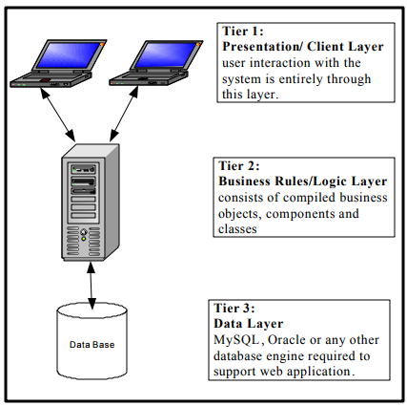

**Fig. ?.** Proposed System

**(For Informatics Major)**

**CHAPTER 3: TECHNOLOGIES**

* 1. **Server/Client Technologies**

To implement any web-based application a web server is required. A web server is a piece of software that manages web pages and makes them available to the ‘client’ browser – via a local network or over the Internet. The web server can be accessed remotely or locally. There are many web servers available such as Apache, Internet Information Services IIS, Netscape Web Server and so on.

By typing a URL (Uniform Resource Locator) into the address box of the browser the communication between a browser and a web server is started. Each conversation consists of two pieces:

• a request for information from the browser software and

• a response from the server addressed by the URL.

The principle of communication between a client and a server is composed of successions of requests and responses. This communication is shown in Figure ?

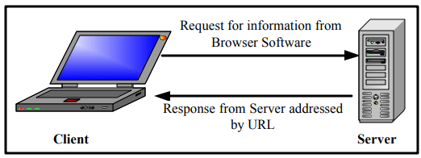

**Fig. ?.** Communication between client and web-server

* 1. **Web or Mobile Technologies**

<<Describe the web (ASP>NET) or mobile technologies (ANDROID) >>

* 1. **Computing Technologies**

MATLAB Production Server™ is the run-time framework for integrating [MATLAB®](https://www.mathworks.com/products/matlab.html) based analytics into enterprise applications. It manages the running of different MATLAB analytics that require different versions of the [MATLAB Runtime](https://www.mathworks.com/products/compiler/matlab-runtime.html) in response to large numbers of concurrent work requests from enterprise systems such as databases, web servers, and application servers.

When used together, MATLAB, [MATLAB Compiler SDK™](https://www.mathworks.com/products/matlab-compiler-sdk.html), and MATLAB Production Server enable the rapid development of custom analytics, their integration into enterprise applications, and their deployment within production environments without recoding or creating custom infrastructure.

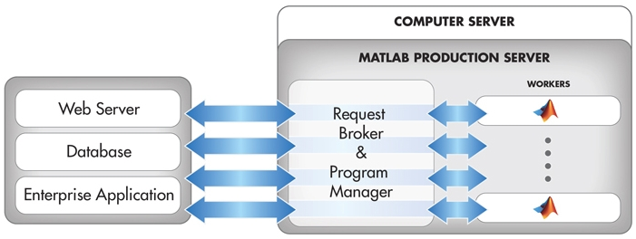

**Fig. ?.** Running MATLAB analytics as a part of web, database, and enterprise applications

* 1. **Connection Database Technologies**

MySQL is a software package that enables the creation, maintenance and management of database. MySQL is a Structured Query Language (SQL) based, client/server relational database. Each of these terms describes a fundamental part of the architecture of MySQL Server

MySQL’s specific design goals were speed, robustness and ease of use. To improve the performance, MySQL was made as a multithreaded database engine. A multithreaded application performs many tasks at the same time as if multiple instances of that application were running simultaneously. Multithreaded applications have a lower overhead cost, when compared with multi processed databases.

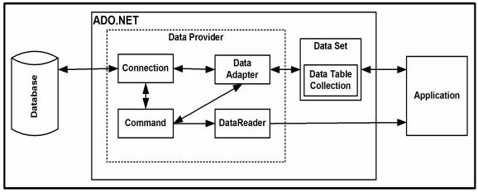

**Fig. ?.** ADO.NET architecture

**(For Informatics Major)**

**CHAPTER 4: APPLICATION**

* 1. **Administrator Applicant**

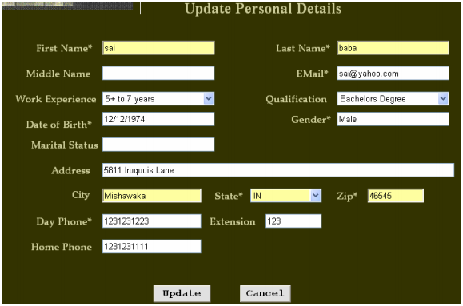

**Fig. ?.** Administrator Update Action

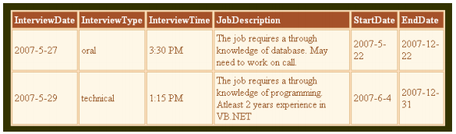

**Fig. ?.** Administrator View

* 1. **User 1 Applicant**

The Contact can update his/her personal or company information, add new job or update existing job and add evaluations. The Contact can also view the interview schedule and evaluation of the Applicants. Figure 45 shows the page to update personal information while Figure 46 shows the page to update company information.

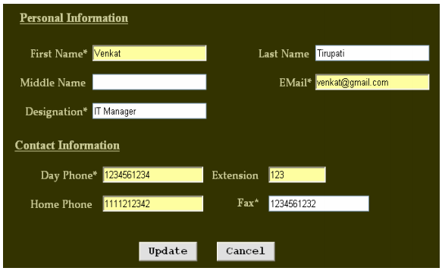

**Fig. ?.** User 1 Update Personal Information

* 1. **User 2 Applicant**

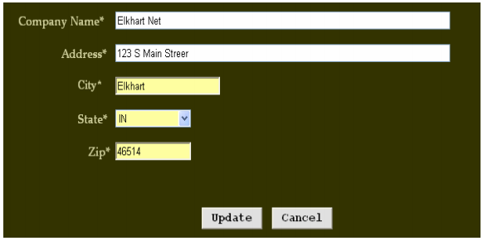

**Fig. ?.** User 2 Update Company Information

* 1. **Computing Results**

<< Show result of computing process if available>>

**(For Both Majors)**

**CHAPTER 5: DISCUSSION**

* 1. **Benefits of Proposed Approach**
  2. **Limitations** **of Proposed Approach**
  3. **Future Works**

**CONCLUSIONS**

In this paper, we discuss and evaluate main image segmentation techniques used for the purpose of image analysis. It is found that there is no perfect method for image segmentation because the result of image segmentation is depends on many factors, i.e., pixel color, texture, intensity, similarity of images, image content, and problem domain. Therefore, it is not possible to consider a single method for all type of images nor all methods can perform well for a particular type of image. Hence, it is good to use hybrid solution consists of multiple methods for image segmentation problem.

**APPENDIX A**

Example of an Appendix

This appendix contains vital information.

**APPENDIX B**

Example of an Appendix

This appendix contains vital information.

**REFERENCES**

*Basic format for books:*

1. J. K. Author, “Title of chapter in the book,” in *Title of His Published Book, x*th ed. City of Publisher, Country if not
2. USA: Abbrev. of Publisher, year, ch. *x*, sec. *x*, pp. *xxx–xxx.*

*Examples:*

1. G. O. Young, “Synthetic structure of industrial plastics,” in *Plastics,* 2nd ed., vol. 3, J. Peters, Ed. New York: McGraw-Hill, 1964, pp. 15–64.
2. W.-K. Chen, *Linear Networks and Systems.* Belmont, CA: Wadsworth, 1993, pp. 123–135.

*Basic format for periodicals:*

1. J. K. Author, “Name of paper,” *Abbrev. Title of Periodical*, vol. *x,* no. *x,* pp*. xxx-xxx,* Abbrev. Month, year.

*Examples:*

1. J. U. Duncombe, “Infrared navigation—Part I: An assessment   
   of feasibility,” *IEEE Trans. Electron Devices*, vol. ED-11, no. 1, pp. 34–39, Jan. 1959.
2. E. P. Wigner, “Theory of traveling-wave optical laser,” *Phys. Rev*.,   
   vol. 134, pp. A635–A646, Dec. 1965.
3. E. H. Miller, “A note on reflector arrays,” *IEEE Trans. Antennas Propagat*., to be published.

*Basic format for reports:*

1. J. K. Author, “Title of report,” Abbrev. Name of Co., City of Co., Abbrev. State, Rep. *xxx*, year.

*Examples:*

1. E. E. Reber, R. L. Michell, and C. J. Carter, “Oxygen absorption in the earth’s atmosphere,” Aerospace Corp., Los Angeles, CA, Tech. Rep. TR-0200 (4230-46)-3, Nov. 1988.
2. J. H. Davis and J. R. Cogdell, “Calibration program for the 16-foot antenna,” Elect. Eng. Res. Lab., Univ. Texas, Austin, Tech. Memo. NGL-006-69-3, Nov. 15, 1987.

*Basic format for handbooks:*

1. *Name of Manual/Handbook*, *x* ed., Abbrev. Name of Co., City of Co., Abbrev. State, year, pp. *xxx-xxx.*

*Examples:*

1. *Transmission Systems for Communications*, 3rd ed., Western Electric Co., Winston-Salem, NC, 1985, pp. 44–60.
2. *Motorola Semiconductor Data Manual*, Motorola Semiconductor Products Inc., Phoenix, AZ, 1989.

*Basic format for books (when available online):*

1. Author. (year, month day). *Title.* (edition) [Type of medium]. *volume (issue).* Available: site/path/file

*Example:*

1. J. Jones. (1991, May 10). *Networks.* (2nd ed.) [Online]. Available: [http://www.atm.com](http://www.atm.com/)

*Basic format for journals (when available online):*

1. Author. (year, month). Title. *Journal.* [Type of medium]. *volume (issue),* pages. Available: site/path/file

*Example:*

1. R. J. Vidmar. (1992, Aug.). On the use of atmospheric plasmas as electromagnetic reflectors. *IEEE Trans. Plasma Sci.* [Online]. *21(3),* pp. 876–880. Available:<http://www.halcyon.com/pub/journals/21ps03-vidmar>

*Basic format for papers presented at conferences (when available online):*

1. Author. (year, month). Title. Presented at Conference title. [Type of Medium]. Available: site/path/file

*Example:*

1. PROCESS Corp., MA. Intranets: Internet technologies deployed behind the firewall for corporate productivity. Presented at   
   INET96 Annual Meeting. [Online]. Available: <http://home.process.com/Intranets/wp2.htp>

*Basic format for reports and handbooks (when available online):*

1. Author. (year, month). Title. Comp an y . C ity, State or Country. [Type of Medium]. Available: site/path/file

*Example:*

1. S. L. Tall een. (1996 , Apr . ). The In t r an et Archi -tecture: M a nagi ng i n f o rm at i on i n t h e ne w paradigm. Amdahl Corp., CA. [Online]. Available:<http://www.amdahl.com/doc/products/bsg/intra/infra/html>

*Basic format for computer programs and electronic documents (when available online):* ISO recommends that capitalization follow the accepted practice for the language or script in which the information is given.

*Example:*

1. A. Harriman. (1993, June). Compendium of genealogical software. *Humanist.* [Online]. Available e-mail: [HUMANIST@NYVM.ORG](mailto:HUMANIST@NYVM.ORG) Message: get GENEALOGY REPORT

*Basic format for patents (when available online):*

1. Name of the invention, by inventor’s name. (year, month day). *Patent Number* [Type of medium]. Available: site/path/file

*Example:*

1. Musical toothbrush with adjustable neck and mirror, by L.M.R. Brooks. (1992, May 19). *Patent D 326 189*

[Online]. Available: NEXIS Library: LEXPAT File: DESIGN

*Basic format for conference proceedings (published):*

1. J. K. Author, “Title of paper,” in *Abbreviated Name of Conf.*, City of Conf., Abbrev. State (if given), year, pp. *xxxxxx.*

*Example:*

1. D. B. Payne and J. R. Stern, “Wavelength-switched pas- sively coupled single-mode optical network,” in *Proc. IOOC-ECOC,* 1985,   
   pp. 585–590.

*Example for papers presented at conferences (unpublished):*

1. D. Ebehard and E. Voges, “Digital single sideband detection for interferometric sensors,” presented at the 2nd Int. Conf. Optical Fiber Sensors, Stuttgart, Germany, Jan. 2-5, 1984.

*Basic format for patents:*

1. J. K. Author, “Title of patent,” U.S. Patent *x xxx xxx*, Abbrev. Month, day, year.

*Example:*

1. G. Brandli and M. Dick, “Alternating current fed power supply,”   
   U.S. Patent 4 084 217, Nov. 4, 1978.

*Basic format**for theses (M.S.) and dissertations (Ph.D.):*

1. J. K. Author, “Title of thesis,” M.S. thesis, Abbrev. Dept., Abbrev. Univ., City of Univ., Abbrev. State, year.
2. J. K. Author, “Title of dissertation,” Ph.D. dissertation, Abbrev. Dept., Abbrev. Univ., City of Univ., Abbrev. State, year.

*Examples:*

1. J. O. Williams, “Narrow-band analyzer,” Ph.D. dissertation, Dept. Elect. Eng., Harvard Univ., Cambridge, MA, 1993.
2. N. Kawasaki, “Parametric study of thermal and chemical nonequilibrium nozzle flow,” M.S. thesis, Dept. Electron. Eng., Osaka Univ., Osaka, Japan, 1993.

*Basic format for the most common types of unpublished references:*

1. J. K. Author, private communication, Abbrev. Month, year.
2. J. K. Author, “Title of paper,” unpublished.
3. J. K. Author, “Title of paper,” to be published.

*Examples:*

1. A. Harrison, private communication, May 1995.
2. B. Smith, “An approach to graphs of linear forms,” unpublished.
3. A. Brahms, “Representation error for real numbers in binary computer arithmetic,” IEEE Computer Group Repository, Paper R-67-85.

*Basic format for standards:*

1. *Title of Standard*, Standard number, date.

*Examples:*

1. IEEE Criteria for Class IE Electric Systems, IEEE Standard 308, 1969.

Letter Symbols for Quantities, ANSI Standard Y10.5-1968